Essential Terminology:
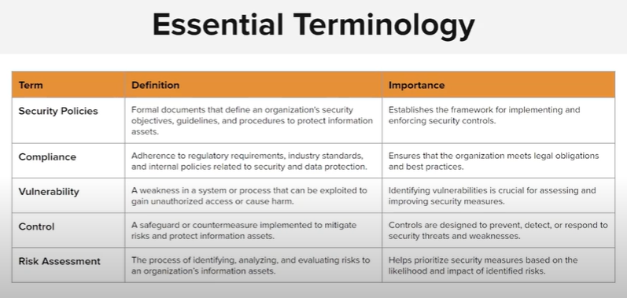
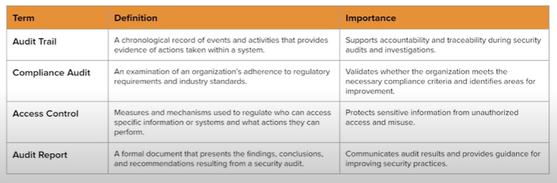

Audit trail = the evidence or logs created during normal system use (like login attempts, file changes, transactions) that auditors review to verify what happened.

